Table Of Contents
Table Of Contents 3
Introduction 4
1. Current Issues 4
2. Objective of study 5
3. Project to be developed (Ez2Learn) 6
4. Problem Statement 8
5. Background of Project 9
6. Development Methodology 11
Method of development 11
7. Module for each member 13
Module 1: User Management 13
Module 2: Manage Learning Material Module 15
Module 3: Manage Assignments & Assessments 16
Module 4: Progress Tracking 18
8. Expected Outcome 19
Prototype 20
Module 1: User Management (CB23128) 20
Module 2: Manage Learning Material Module (CB22049) 24
Module 3: Manage Assignments & Assessments (CB22163) 29
Module 4: Progress Tracking (CB23007) 32
9. Conclusion 36
10. References 37

1. Project Proposal
1.1 Introduction

1.1.1 Current Issues

At University Malaysia Pahang Al-Sultan Abdullah (UMPSA), students often face difficulty in accessing structured, high-quality learning materials outside regular class hours. Most online learning content depends entirely on individual lecturers’ efforts–some may upload videos or notes on external platforms like YouTube, while many others do not. As a result, students who wish to revise lessons, explore new topics, or learn additional skills beyond their coursework have limited options.

The lack of a centralized e-learning platform within the university limits opportunities for self-paced learning, knowledge retention, and continuous academic development. This also affects the quality of the learning experience, as materials are scattered, unorganized, and inconsistent across courses and lecturers.

Our focus in this project is therefore on improving the software quality attributes such as usability, reliability, and maintainability, ensuring that the platform provides a consistent, easy-to-use, and dependable environment for learning. The goal is not only to build functional software but also to ensure that its quality meets the expectations of both students and lecturers.

1.1.2 Objective of study

The objective of this study is to develop a functional and user-friendly e-learning platform called Ez2Learn, designed to simplify the learning experience by providing an accessible and interactive online environment. Inspired by Coursera, the system allows users to learn new skills, explore various subjects, and earn completion certifications in one centralized platform. Ez2Learn consists of four main modules: User Management, Learning Materials Management, Assignment Management, and Progress Tracking. The study focuses on creating an intuitive interface with easy navigation to enhance user engagement and learning efficiency. In addition, emphasis will be placed on ensuring system responsiveness, data security, and scalability to support future improvements. This research aims to provide valuable insights into the development of a simplified and effective e-learning system that encourages continuous learning and skill development in a digital setting.

1.1.3 Project to be developed (Ez2Learn)

The Ez2Learn project is a modern and user-friendly e-learning platform developed to address the growing challenges faced by university students in accessing quality online learning materials and structured courses outside of regular class hours. In many academic environments, including Universiti Malaysia Pahang Al-Sultan Abdullah (UMPSA), there is currently no centralized system that offers flexible online courses, video lectures, quizzes, and certification for self-paced learning. Ez2Learn aims to bridge this gap by providing an organized, interactive, and easily accessible digital learning environment where students can explore new subjects, acquire skills, and learn at their own pace.
The system is designed with inspiration from popular online learning platforms such as Coursera but tailored to suit the needs of university students and educators. It will serve as a centralized learning hub where users can browse courses, access lecture materials, complete assignments, and monitor their learning progress. Through its intuitive and responsive interface, Ez2Learn ensures that users can seamlessly navigate between modules, view learning content, and track performance with minimal effort. The platform’s structure emphasizes accessibility and engagement, allowing students to take control of their learning experience anytime and anywhere.
One of the core strengths of Ez2Learn lies in its four main modules: User Management, Learning Materials Management, Assignment Management, and Progress Tracking. The User Management module enables administrators to manage user accounts and assign appropriate roles for students and instructors. The Learning Materials Management module allows instructors to upload video lectures, notes, and supplementary materials that students can easily access. Meanwhile, the Assignment Management module provides tools for creating, submitting, and grading assignments in an organized manner. Lastly, the Progress Tracking module helps both students and instructors monitor learning outcomes, quiz results, and completion statuses, ensuring transparency and motivation for continuous improvement.
To promote effective online learning, Ez2Learn will integrate interactive features such as quizzes, discussion forums, and completion certificates. These features not only encourage active participation but also help students showcase their achievements. Furthermore, the platform will prioritize responsiveness, security, and scalability, ensuring a smooth user experience across devices while protecting user data.
Ultimately, the Ez2Learn project aims to become a comprehensive and sustainable digital learning solution that supports both academic and personal growth. By creating a centralized platform that simplifies access to learning materials and supports flexible, self-paced education, Ez2Learn seeks to enhance the quality of online learning at UMPSA and inspire a culture of lifelong learning among students.

1.2 Problem Statement

At Universiti Malaysia Pahang Al-Sultan Abdullah (UMPSA), many students struggle to access well-organized and reliable learning materials outside of their regular classes. Most resources are shared through different platforms like Google Drive, YouTube, or personal lecturer pages, which makes it difficult for students to keep track of what they need. Because everything is scattered, students often waste time searching for notes or lecture videos instead of focusing on learning. Without a single, centralized system, studying becomes less convenient and harder to manage, especially for those who prefer to revise or learn at their own pace.

Another issue is the inconsistency in how lecturers share materials. Some lecturers upload complete sets of notes and video lectures, while others only share minimal content or none at all. This unevenness means that some students have access to plenty of resources, while others are left behind. It creates an imbalance in learning opportunities and affects how well students can prepare for exams or explore new topics independently.

Lastly, learning outside the classroom often feels one-sided and less engaging. Since there is no proper e-learning platform, students have fewer chances to take part in interactive learning activities such as quizzes, discussions, or self-assessments. Lecturers also find it hard to monitor students’ progress or give timely feedback. As a result, many students lose motivation, and their learning experience becomes less effective.

1.2 Background of Project
In recent years, online education has transformed how students access knowledge and develop new skills. Global e-learning platforms such as Coursera, Udemy, and edX have set a new standard for flexible, self-paced learning. However, most universities–including Universiti Malaysia Pahang Al-Sultan Abdullah (UMPSA). Still lack an internal system that offers similar functionality tailored to their students’ needs.
Currently, UMPSA students depend heavily on traditional classroom teaching or informal resources shared through messaging apps and scattered links. While this may work for routine coursework, it limits students who wish to study independently, revise lessons, or learn additional subjects beyond their syllabus. This lack of a centralized, high-quality online learning environment inspired the development of Ez2Learn.
Ez2Learn is designed as a comprehensive yet simplified online learning platform that combines the essential features of global learning systems with the specific requirements of UMPSA students and lecturers. It focuses on quality, accessibility, and ease of use, ensuring that learning can happen anytime, anywhere.
Main features of Ez2Learn:

  - User Management System
    - Three types of users: Admin, Lecturer, and Student.
    - Secure registration and login for all users.
    - Admins manage roles, content approvals, and account maintenance.
  - Course Management
    - Lecturers can create, edit, and manage courses.
    - Each course can include video lectures, reading materials, and quizzes.
    - Students can browse available courses and enroll with one click.
  - Video lecture library
    - High-quality instructional videos uploaded by lecturers.
    - Students can stream or re-watch content at their own pace.
    - Video playback history and progress tracking ensure continuity.
  - Interactive Quizzes and Assessments
    - Each course includes auto-graded quizzes to test understanding.
    - Students receive instant feedback and can review incorrect answers.
  - Certificate of Completion
    - Upon completing all modules and quizzes, the system automatically generates a digital certificate.
    - Certificates can be downloaded or shared on professional platforms such as LinkedIn.
  - Progress Tracking Dashboard
    - Personalized dashboards for students showing completed courses, scores, and ongoing progress.
    - Lecturers can monitor student performance and participation levels.
  - Quality and Usability Focus
    - Emphasis on software quality assurance, ensuring that all components are reliable, user-friendly, and maintainable.
    - Usability testing and continuous feedback will help refine the interface design, loading performance, and content delivery.

1.4 Development Methodology

1.4.1 Method of development
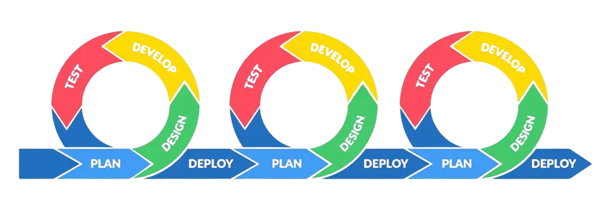
For the development of Ez2Learn, our team has chosen to follow the Agile Scrum methodology. One of the most adaptable and useful methods for software development is scrum, especially for student projects where collaboration, communication, and incremental improvement are essential [1].

Instead of building the whole system at once, we will develop, test, and
improve each part step by step. This approach allows us to adapt easily if any issues or new ideas come up during the process. This method will keep us on track, improve our productivity, and guarantee that our system is getting better with each iteration. It also encourages regular team discussions and updates, which makes problem-solving faster and helps maintain good coordination between members [2].

Additionally, Scrum supports continuous testing, feedback, and improvement throughout the development cycle, which matches the principles of Software Quality Assurance (SQA). Each sprint includes evaluating and improving the features to identify and resolve problems early instead of waiting until the end to test the system. This helps improve the system’s usability, reliability, and maintainability, which are the key goals of the Ez2Learn project.

Module for each member

Module 1: User Management
Create:
The system allows new users, including students and lecturers, to sign up and create their own accounts to gain full access to the Ez2Learn platform. During registration, users are required to provide basic information such as name, email, password, and role selection (student or lecturer). Once registered, users can log in to access personalized features such as students can browse and learn from uploaded materials, while lecturers can manage and upload course content. This feature ensures a secure and structured entry point for all users of the system.
Read:
Both students and lecturers can view their personal profiles and access stored information such as their name, email, and activity history. The system provides a simple dashboard where users can track their recent activities, such as uploaded materials (for lecturers) or viewed courses (for students). Administrators can also view a summary of all user accounts for monitoring and maintenance purposes.
Update:
Users can update their profile information, including name, password, and profile picture, through the settings page. Lecturers may also edit their profile descriptions to display professional or academic background. This ensures that user information remains current and helps create a more personalized learning environment. Administrators retain the ability to modify or reset user credentials if necessary.
Delete:
Users can deactivate their own accounts if they wish to stop using the platform, while administrators can remove inactive or inappropriate accounts to maintain system security. When an account is deleted, the system ensures that personal data and related records are handled securely to protect user privacy. This keeps the Ez2Learn platform organized, safe, and trustworthy for all users.

Module 2: Manage Learning Material Module
Create:
The system allows lecturers to upload and create new learning materials such as lecture notes, slides, videos, and supplementary reading documents. During the upload process, lecturers can provide essential details including the course title, description, and file type. This feature enables lecturers to continuously add updated and relevant learning resources for their students. The ability to create and organize materials ensures that students have access to high-quality educational content that supports flexible and self-paced learning.
Read:
Both lecturers and students can access the list of uploaded learning materials through a user-friendly interface. Students can view and download course materials or watch video lectures directly from the platform, while lecturers can view all materials they have uploaded along with the number of student views or downloads. The system also includes search and filter options that allow users to find specific materials based on subject, course name, or upload date, ensuring smooth and efficient access to content.
Update:
Lecturers have the ability to edit or update their existing learning materials to ensure the accuracy and relevance of the content. This includes modifying titles, updating file descriptions, replacing outdated documents, or adding new versions of lecture videos. This feature helps maintain up-to-date course information and ensures students always receive the most current materials for their studies.
Delete:
Lecturers can remove outdated, duplicated, or irrelevant learning materials from the system to keep their course content organized and consistent. If certain materials are no longer necessary or need to be replaced, lecturers can delete them from their course list. This ensures that students have access only to accurate and approved materials, maintaining the overall quality and credibility of the Ez2Learn platform.

Module 3: Manage Assignments & Assessments
The Manage Assignments & Assessments module goal is to help both lecturers and students handle course tasks in an easy and efficient way. It gives lecturers an easy way to develop and manage assignments or quizzes, while students can submit their work, check deadlines, and review their results in a single platform.

Create:
Lecturers can create new assignments or quizzes for their courses and add important details like the title, description, due date, and total score. They can also upload important materials such as instructions or test questions for tests or an assignment. When a lecturer creates a new task, it automatically appears in the student’s dashboard and makes it easy for students to know what needs to be done.

Read:
Students can view all their assignments, deadlines, and marks in an orderly list. Also, they can read the instructions on the platform or download the files. While instructors may see all the assignments they created, monitor student's work, and grade every assignment.

Update:
Lecturers may need to make changes after an assignment has been created. They can edit information like the due date, grades, and even upload new files. Students can also update their submission before the deadline if they want to upload a revised version. This ability to change ensures that there won't be any misunderstandings or technological issues when both sides manage their tasks.

Delete:
Lecturers can remove old or unnecessary assignments to keep their course page tidy. Administrators also have permission to remove any duplicate or invalid entries to maintain system quality. When something is deleted, the system ensures that related data, such as student submissions and so on, are properly handled or deleted to keep the platform clean and secure.

Module 4: Progress Tracking
The Progress Tracking module helps students, lecturers, and administrators monitor learning progress throughout each course. It keeps track of how much a student has completed, their quiz results, and whether they are eligible to receive a completion certificate. This module ensures that both students and lecturers can easily see learning achievements in a clear and organized way.
Create:
New progress records are automatically created when a student enrolls in a course or starts a lesson. Each time the student completes a video or submits a quiz, the system records their progress and updates the course completion percentage.

Read:
Students can view their current progress, grades, and completion status for every course on their dashboard. Lecturers can read progress reports for their students to identify who has completed tasks or needs improvement. Admins can access all progress data to ensure system accuracy.
Update:
Progress is updated automatically whenever students complete new lessons, quizzes or assignments. Lecturers can also update the grading record when scores are modified. The system keeps the progress information consistent with the latest student activities.
Delete:
If a student withdraws from a course or if any invalid progress data is detected, administrators can delete the related records. This keeps the database clean and ensures that all progress reports remain accurate and up to date.

Expected Outcome
It is expected that the Ez2Learn platform will provide a reliable, secure, and easy to use online learning platform that will help both lecturers and students at Universiti Malaysia Pahang Al-Sultan Abdullah. By the end of this project, the team aims to develop a functional web based system that supports essential teaching and learning activities with its four primary modules: Assignments & Assessments, Learning Materials Management, User Management, and Progress Tracking.

It will be expected that the system will make it simple for students to access course materials, finish assignments, and track their progress in an efficient way. At the same time, lecturers will be able to manage courses, upload content, and evaluate student performance more easily. To ensure that all data, including user information, submitted materials, and assessment records, can be created, read, updated, and removed without any problems, the platform will also have basic CRUD functionalities.

The project aims to create a system that offers high quality of usability, dependability, maintainability, and security in terms of software quality. The user interface will be responsive and easy to use, ensuring uninterrupted device navigation.The team also expects to gain valuable experience in applying software quality assurance practices such as documentation, testing, and version control throughout the development process.

Overall, the expected outcome of this project is not only a functional e-learning system but also a representation of how strong cooperation and quality assurance concepts can support the creation of a sustainable beneficial digital learning platform.

Prototype

Module 1: User Management (CB23128)

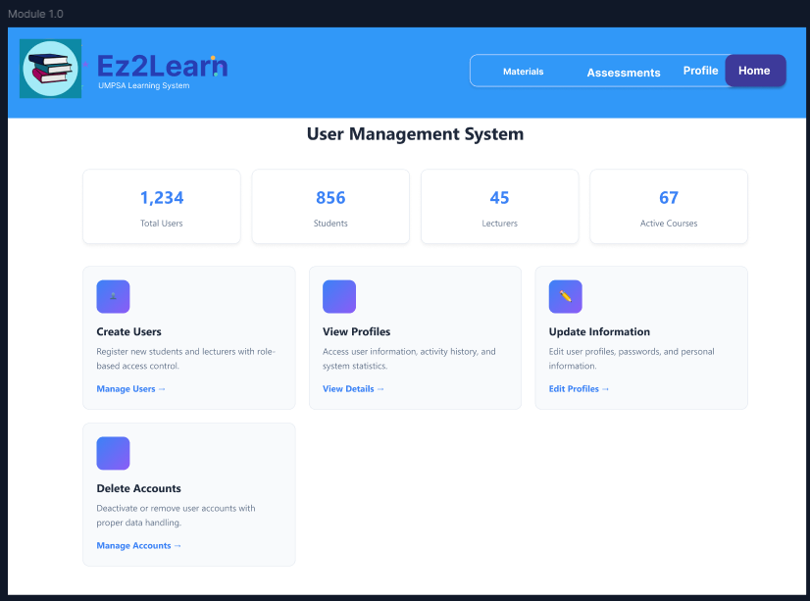

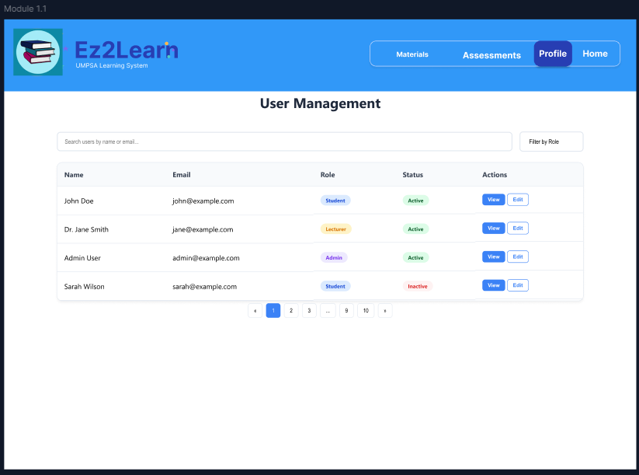
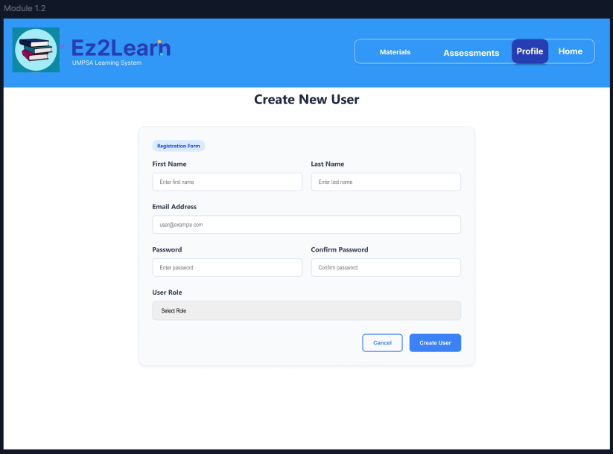
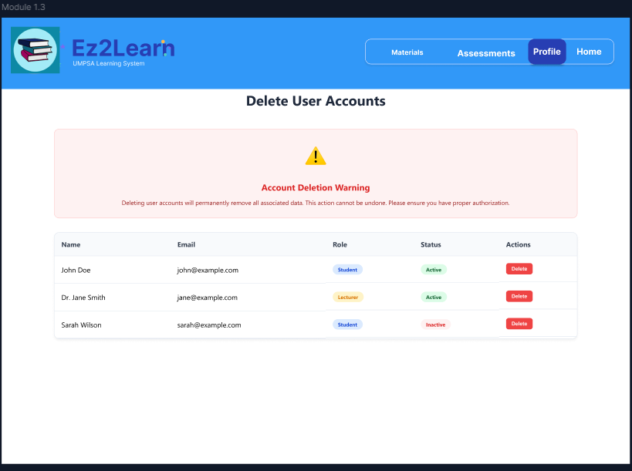
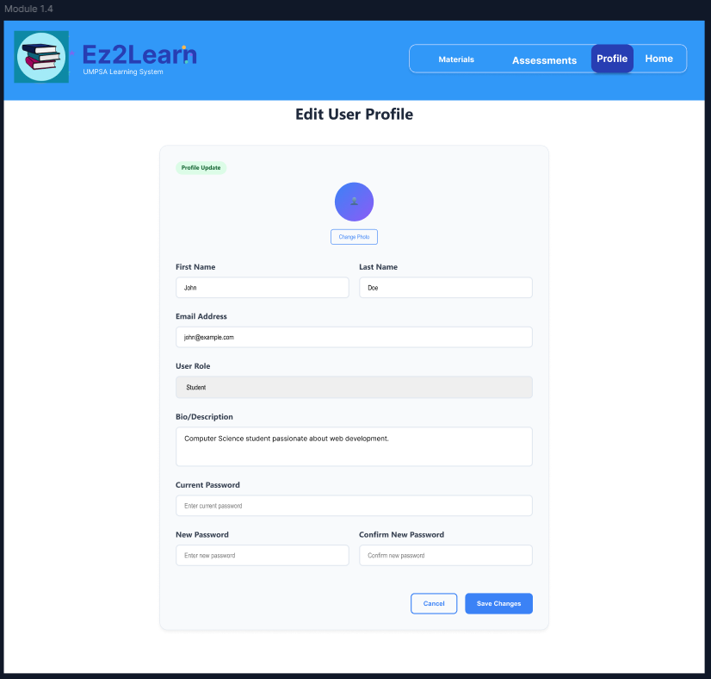

The Ez2Learn User Management System effectively implements the four core functions of user account lifecycle management: Create, Read, Update, and Delete (CRUD). The Create function is handled via the "Create New User" registration form, which captures essential details like name, email, password, and the assignment of a User Role (Student or Lecturer), ensuring a secure and structured onboarding process. The Read function is supported by both the high-level "User Management System" dashboard, which provides administrative statistics on Total Users, Students, and Lecturers, and the detailed "User Management" table, which allows administrators to view all accounts and their respective statuses. The Update capability is executed on the "Edit User Profile" page, allowing users to modify personal information such as name, bio, profile photo, and crucially, to update their password, thereby maintaining current and secure credentials. Finally, the Delete function, accessible via the "Delete User Accounts" page, provides the necessary administrative control to remove accounts, complete with a stark "Account Deletion Warning" to emphasize the permanent nature of the data removal, ensuring compliance with privacy and system security protocols.

Module 2: Manage Learning Material Module (CB22049)

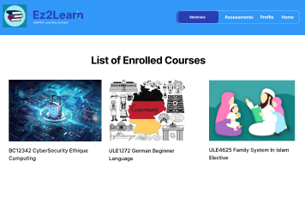
Displays a list of all the courses that the student has registered for within the system. Through this interface, students can easily view essential course details such as the course title, lecturer’s name, and brief description. Each course listed provides quick access to its corresponding learning materials, assignments, and progress tracking features. This page serves as a convenient navigation point for students to manage their academic activities and stay organized throughout their learning journey. It ensures that students can seamlessly access the subjects they are currently taking and monitor their engagement across different courses.

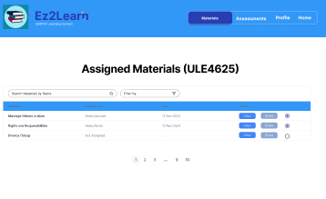
The Learning Materials Dashboard serves as the central hub for students to access all available study resources. On this page, students can conveniently view uploaded materials such as notes, slides, and videos shared by their lecturers. The interface also allows students to share materials with their classmates to encourage collaborative learning. Additionally, students can tick or mark the chapters they have already revised, helping them keep track of their study progress in an organized and interactive way. This dashboard promotes self-paced learning and ensures that students stay engaged and updated with their course content.

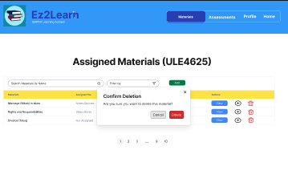

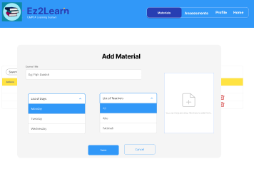
The Add Learning Materials page enables lecturers to upload and manage educational resources for their respective courses. Through this interface, lecturers can input details such as the material title, description, chapter, and attach relevant files like documents, videos, or slides. This page is designed with a simple and user-friendly layout to ensure that lecturers can easily organize and update their teaching materials without technical difficulty.

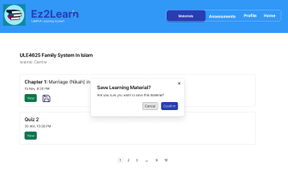

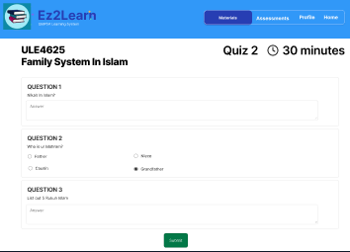
The Quiz Page allows students to test their understanding of the learning materials through interactive quizzes. Each quiz is designed with a built-in timer to encourage focus and simulate real assessment conditions. The interface displays one question at a time, along with multiple-choice answers for easy navigation. Students can track the remaining time through a visible countdown timer, ensuring they manage their time effectively while answering. Once the timer runs out or the student submits the quiz, the system automatically records the responses.

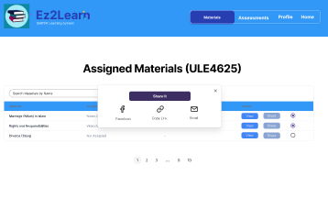

Module 3: Manage Assignments & Assessments (CB22163)

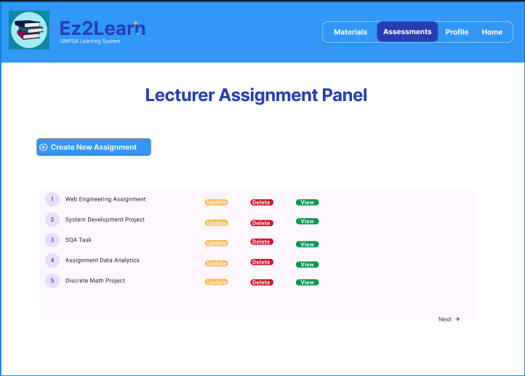
This module allows lecturers to easily manage all course assignments in one place. They can create new assignments, update existing ones, delete outdated tasks, or view detailed submissions.
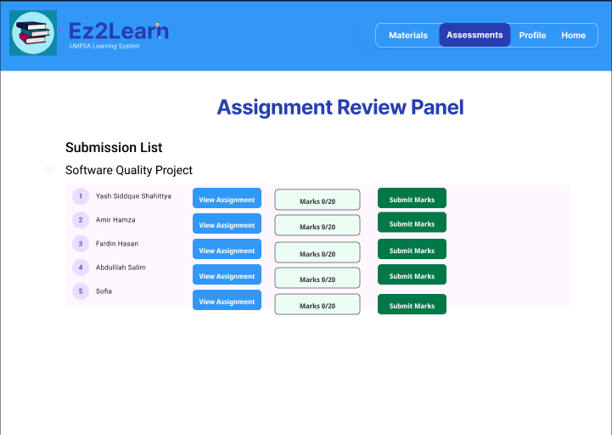
This module enables lecturers to review student submissions efficiently. It displays a clear list of all students who have submitted their assignments, along with options to view the submitted work, assign marks, and submit grades directly.

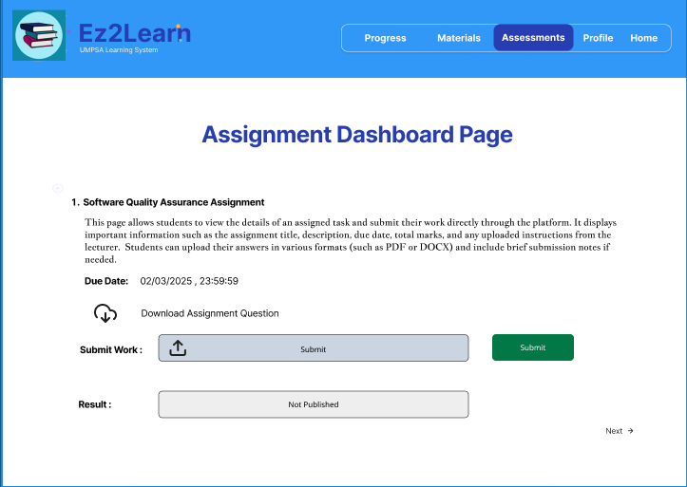
Students may access all of the tasks that their lecturers assigned them in this module, including the due dates, descriptions, and final grades. Each task includes an option to download the assignment question or related files for reference.Students can review their grades once they have been submitted and graded.

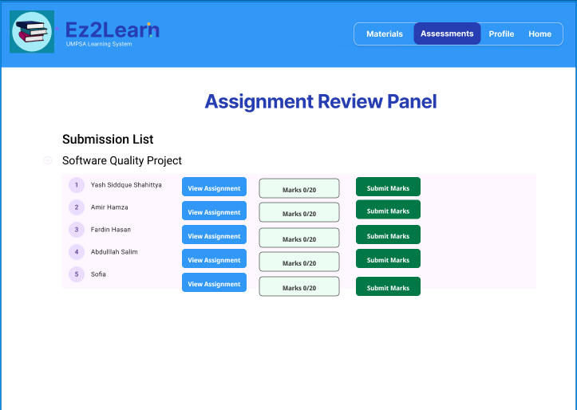

In this module, lecturers can view a list of students who have submitted their assignments for a specific course. Teachers can view each student's submission from this page, review the work that has been submitted, and calculate grades based on that assessment.

Module 4: Progress Tracking (CB23007)
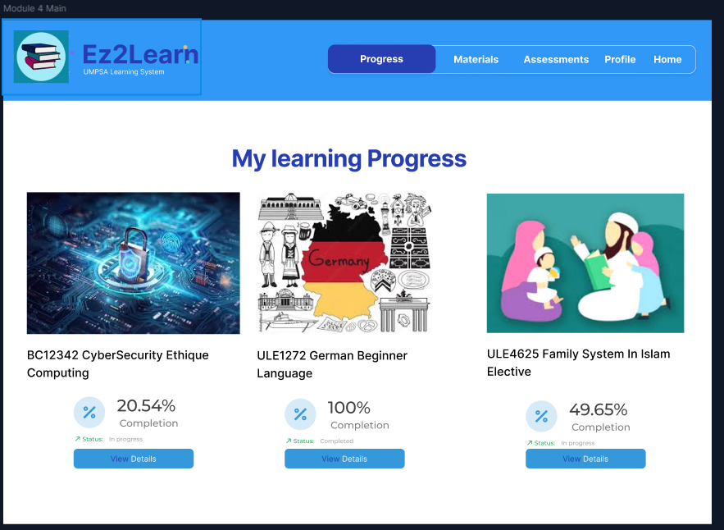
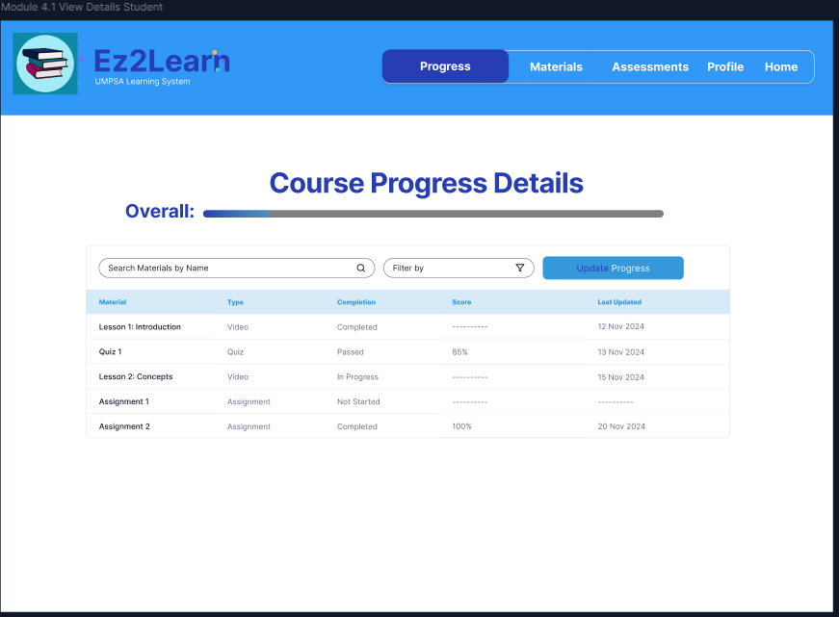
CRUD INTEGRATION DESIGN

CRUD Function | How it appear | How it is represented visually
Create | When a student start a new lesson or quiz | Auto “Start Tracking” tag appears; small toast notification: “Progress tracking started!”
Read | The main dashboard & course details pages | Progress bars, lists, percentage counters, filters by date/course
Update | When a student completes a new material | Smooth progress-bar animation filling up
Delete | Admin/lecturer view | Reset notification pop up after clicking on “RESET” (As showcased in the following design screenshots.
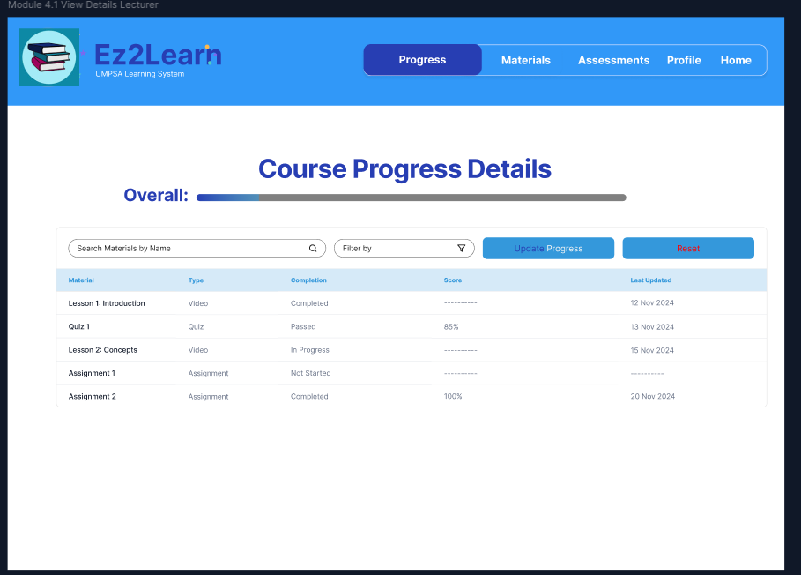
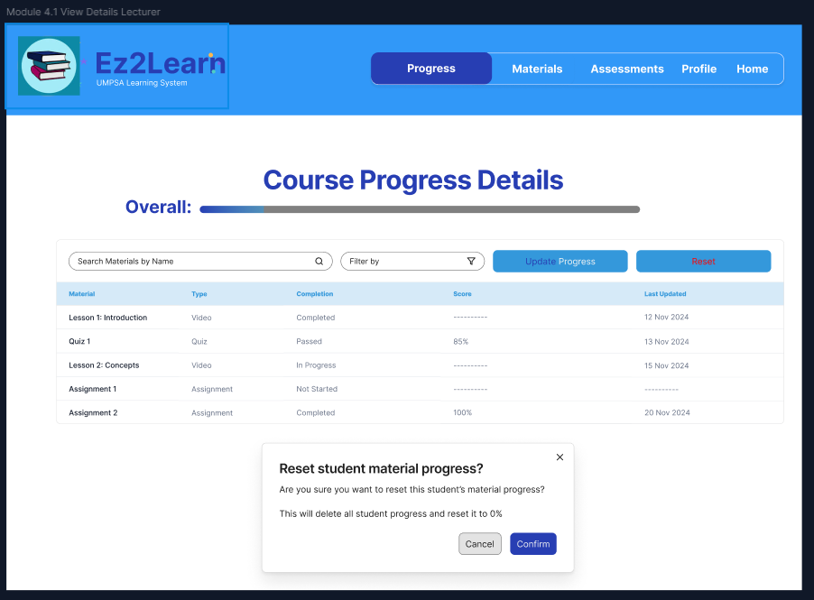

Conclusion

In conclusion, the development of the Ez2Learn platform aims to overcome the main challenges faced by students and lecturers at Universiti Malaysia Pahang Al-Sultan Abdullah (UMPSA) in accessing structured and high-quality online learning materials. By providing a centralized and user-friendly e-learning system, Ez2Learn will make learning more flexible, accessible, and engaging for all users.
The platform’s four key modules, which isUser Management, Learning Materials Management, Assignment Management, and Progress Tracking work together to create a complete digital learning environment. Students will be able to easily access courses, complete assignments, and track their progress, while lecturers can efficiently manage course materials and monitor student performance.
Through the use of the Agile Scrum methodology, the project promotes teamwork, continuous improvement, and adaptability, ensuring that the system meets software quality standards such as usability, reliability, and maintainability.
Overall, Ez2Learn is designed not only as a functional e-learning system but also as a long-term solution that encourages continuous learning, supports academic growth, and enhances the overall learning experience at UMPSA.

References

- J. Pócsová, D. Bednárová, G. Bogdanovská, and A. Mojžišová, “Implementation of agile methodologies in an engineering course,” Educ Sci (Basel), vol. 10, no. 11, 2020, doi: 10.3390/educsci1011033

- B. Carvalho, C. Henrique, and C. Mello, “Scrum agile product development method—literature review, analysis and classification,” Product: Management & Development, vol. 9, pp. 39–49, 2011, doi: 10.4322/pmd.2011.005

- https://www.figma.com/design/EcLtbyWiYnpvTQ1hOyj8o7/ez2learn?node-id=0-1&t=p1xPIMSGPuslro

